Currently PRDP is implementing a project in Kurram Agency of FATA “Protection Assistance to Kurram Agency Returnees (PAKAR)” with the financial assistance of Trocaire-Ireland. The programme is strengthening the protective environment for vulnerable groups through micro-projects in the targeted villages. It is also promoting the well-being through of women and deprived segment of the society through social support centres. The professional staff of PRDP is identifying the protection issues, monitor and referred through community protection groups. Unregistered families, women and child-headed households, people with disabilities and the elderly will be linked with existing service providers and grievance desks.
Activities:
- Training for community-based protection groups
- Micro-grants to community protection groups to improve the protective environment
- Support in receiving legal documentation
- Establishment of Social Support Centers
- Skill training for women and men
- Provision of livelihood support packages
- Linkages with government and other line departments
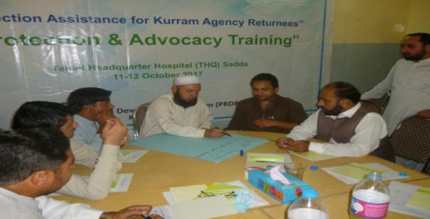
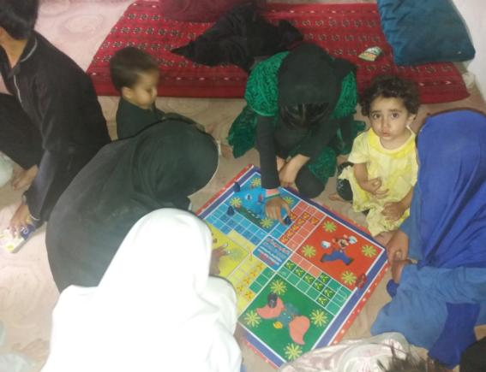
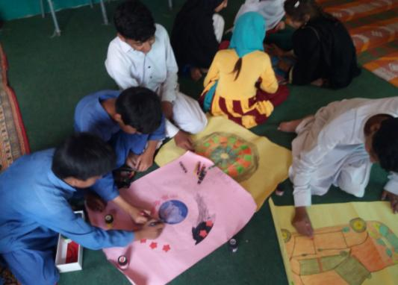
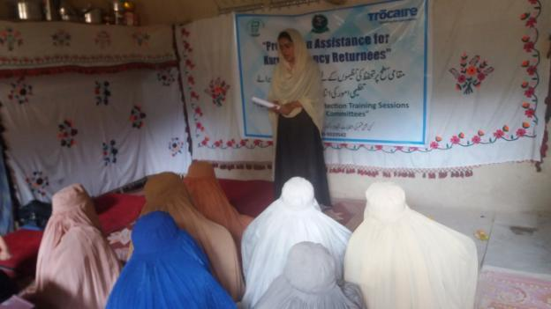
Social Support Center

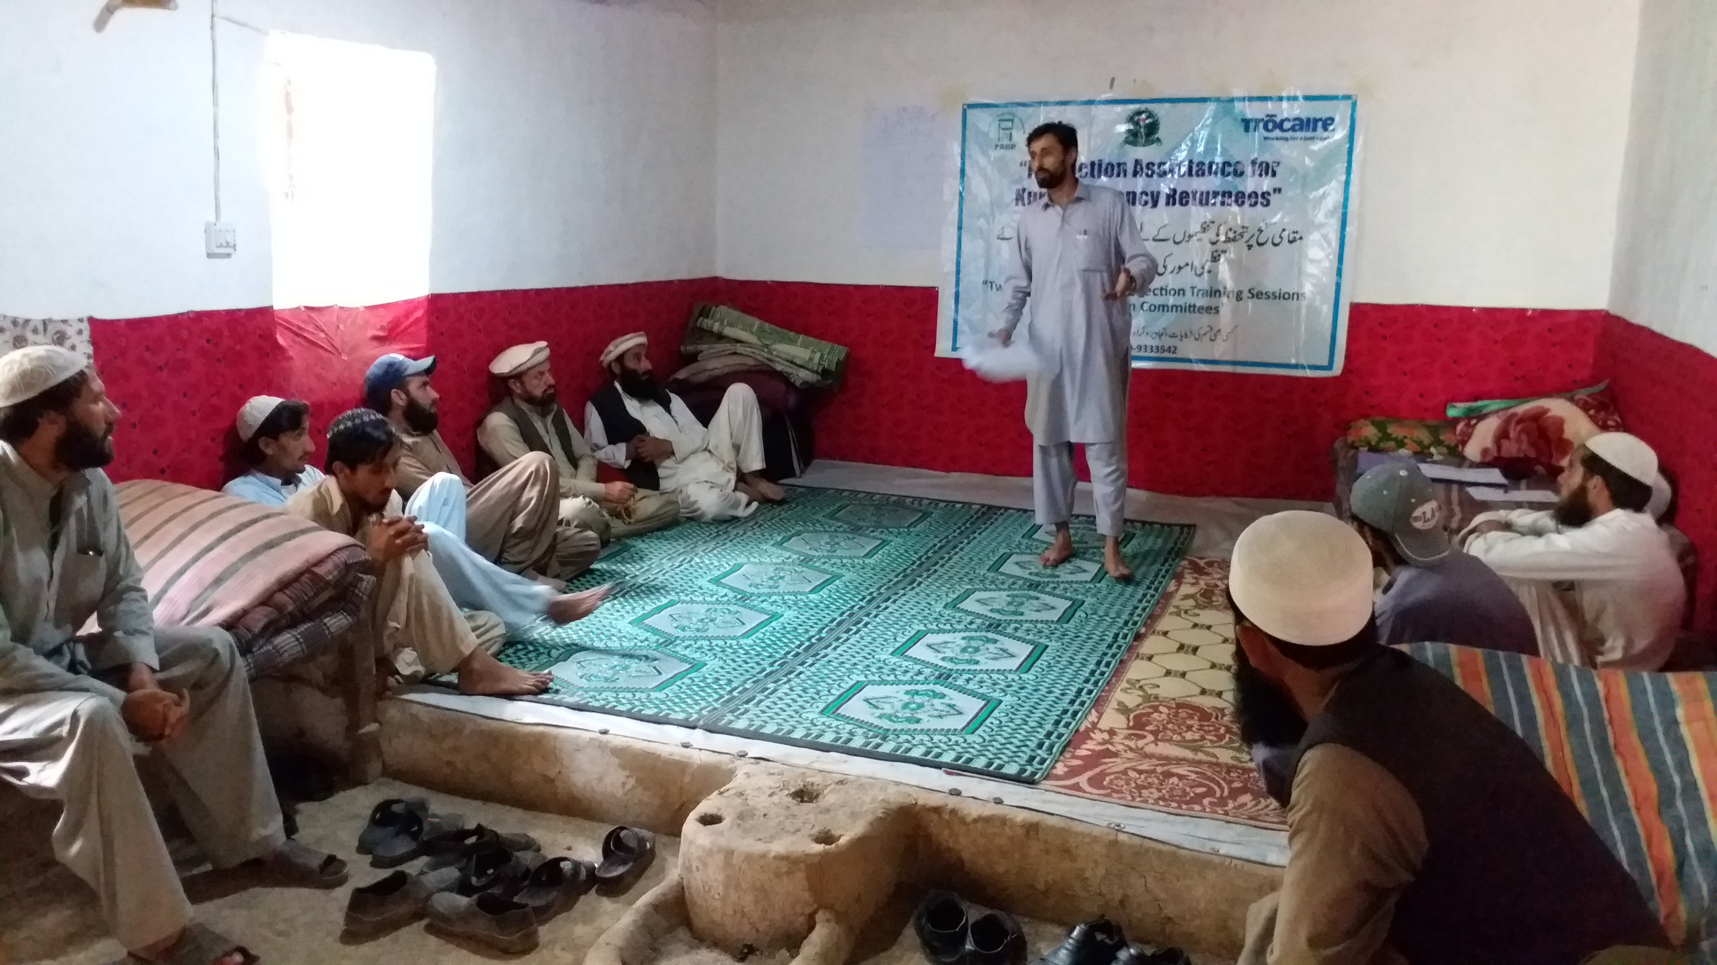
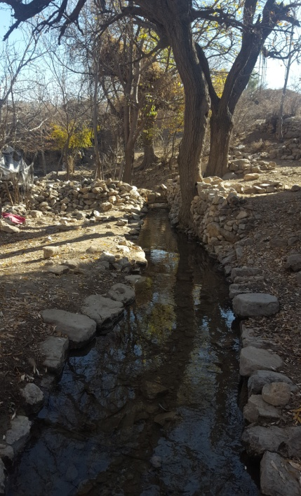
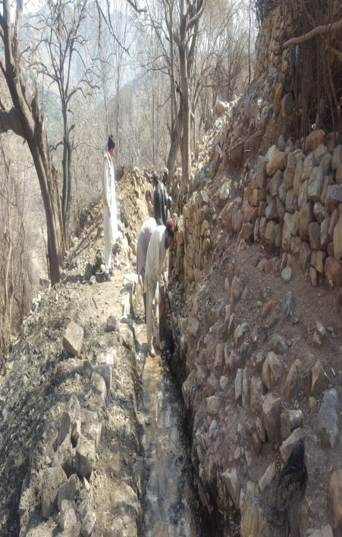
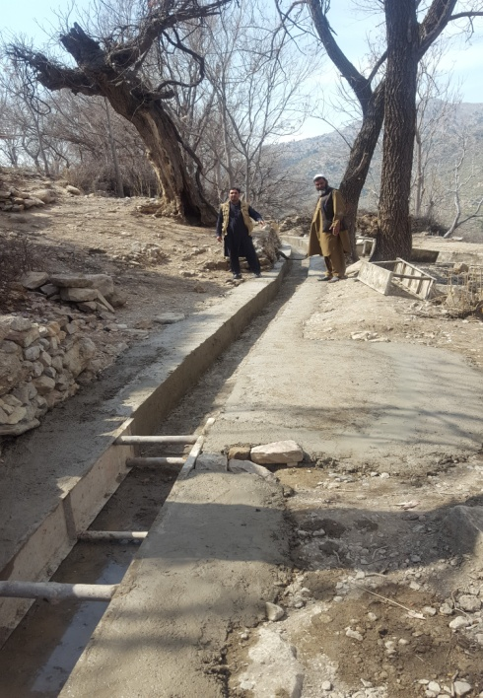
Protection Committee Training
Before During After
Construction of Irrigation Channel

Before | During | After
Construction of Irrigation Channel

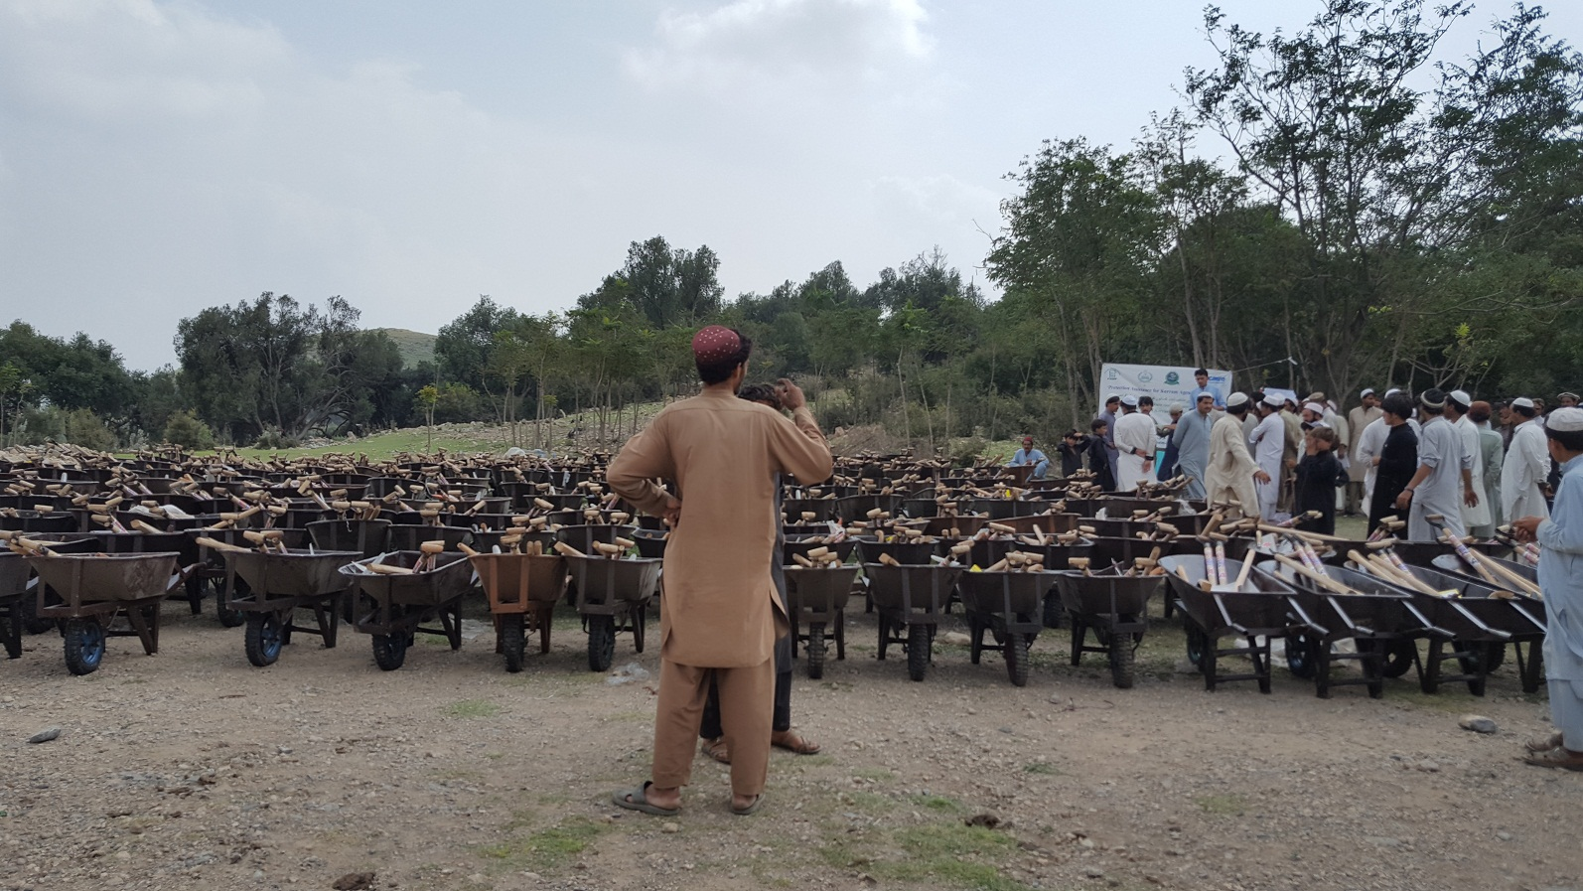
Provision of Agriculture Tool Kits
